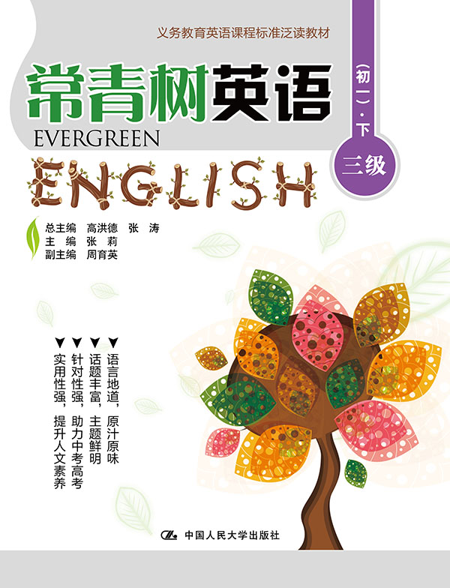
书名：常青树英语 三级（初一）·下
书号：978-7-300-21864-9
作者：高洪德 张涛 张莉
责任编辑：李楠 程子殊
成品：177*228 页数：206
纸张：70克高白胶
装祯：平装
出版时间：2015年9月
定价：37.00元
出版社：中国人民大学出版社

- 本书卖点
- 语言地道、原汁原味
- 话题丰富、主题鲜明
- 针对性强、助力中考高考
- 实用性强、提升人文素养

◆ 读者定位
初中生

- 作者简介
高洪德，山东省教学研究室英语教研员、特级教师，中国教育学会外语教学专业委员会副理事长、山东省教育学会外语教学研究专业委员会理事长。
张涛，山东省教育学会外语教学研究专业委员会秘书长、山东省教学研究室英语教研员。

- 内容简介
本册是参照义务教育阶段《英语课程标准》三级要求编写的，适合七年级学生阅读。本册由61篇文章组成，来源于英、美、加、澳等国经典书刊、报纸、网站等各类媒体，经过数十位初中英语名师反复审读后选定。所选文章兼顾知识性和趣味性，特别注重教化性。

◆ 简要目录
Lesson 1 American Eating
Lesson 2 I Was Lonely, Too
Lesson 3 My Job
Lesson 4 Sun
Lesson 5 Why Do We Yawn?
Lesson 6 Easter Island Statues
Lesson 7 Toys Older than You
Lesson 8 Who Is Your Hero?
Lesson 9 A Letter to My Mum
Lesson 10 My Pen Pal
Lesson 11 My English Teacher
Lesson 12 Mary Green in China
Lesson 13 A Father for Two Hours
Lesson 14 A Robot Teacher
Lesson 15 Barbara Cooney and Her Books
Lesson 16 My Grandparents
Lesson 17 A Busy Mother
Lesson 18 Neighborhood Helpers
Lesson 19 EAST, WEST, SOUTH, NORTH
Lesson 20 Snow Rooms
Lesson 21 How Do You Go to School?
Lesson 22 Old Toys
Lesson 23 New York
Lesson 24 New Suit and Hat
Lesson 25 She Wants to Buy Glasses
Lesson 26 My School Day
Lesson 27 Sandy Beach
Lesson 28 A Computer Whiz-kid
Lesson 29 A Cake Resignation Letter
Lesson 30 Easter Day Eggs
Lesson 31 Just a Quick Nap
Lesson 32 How to Protect Our Eyes
Lesson 33 Important People in My Life
Lesson 34 Meat or Animals?
Lesson 35 Dollar Stores
Lesson 36 The Great Wall
Lesson 37 The Skyscrapers in New York City
Lesson 38 Folk Song Writer—Stephen Foster
Lesson 39 Food Can Be Printed!
Lesson 40 Story of the Three Little Pigs
Lesson 41 A Wonderful Telephone
Lesson 42 Being Active
Lesson 43 Your Bike Helmet
Lesson 44 Trains under the Christmas Tree
Lesson 45 Washington Monument
Lesson 46 Volcanoes
Lesson 47 A Box Full of Kisses
Lesson 48 A Three-year-old Boy Saved His Mum’s Life
Lesson 49 Nick’s New School
Lesson 50 A Maid with Her Basket of Eggs
Lesson 51 It’s Raining!
Lesson 52 Planting Dreams
Lesson 53 The Power of the Violin
Lesson 54 Welcome a Fresh Start for the New Year
Lesson 55 Sing School for Birds
Lesson 56 Who Invented Weekends?
Lesson 57 Why Soccer?
Lesson 58 Thunder and Lightning
Lesson 59 Nicole Kidman: New Hollywood Royalty
Lesson 60 Praise the LORD
Lesson 61 What Will Man Be Like in the Future
Key

◆ 上架建议
中学英语泛读读本

书摘
Lesson 48 A Three-year-old Boy Saved His Mum’s Life
Guidance
Don’t look down upon the children. Sometimes they can do something special, and they can even save your life. Do you believe? 不要小看孩子。有时他们可以做一些特别的事情，而且他们甚至可以挽救你的生命。你相信吗？

A three-year-old boy saved his mum’s life by using her mobile phone to call for help.
One morning, Aaron Green, found his mum Cally Wooton lying on the floor of her bedroom, and was not able to wake her up. He immediately turned to his mum’s Blackberry mobile phone on the bed, opened it, found the address book, and called his mum’s grandmother, even though he had never been shown how to use the phone. Little Aaron told her: Mummy’s sick, she’s very ill.
The grandmother called Cally’s best friend Kara McCoy, who lived nearby. Kara ran to Cally’s house. She found Cally was lying on the bedroom floor. She must have fallen off the bed. She was moving but wouldn’t answer. Kara was scared. She didn’t know what to do. She was helpless, so she called the ambulance ( 救护车).
Cally was sent to hospital and was found that she had a diabetic seizure ( 糖尿病发作). After five days in hospital, Cally was well again.
“Aaron has just started learning his ABC,” Kara said, “but he was very brave and calm. He did better than me. If it wasn’t for Aaron, I wouldn’t be here now. The doctors said I was lucky to be alive.” The boy’s mother said, “I don’t know how he did it. It is not easy to use that phone. It feels like I must have been watched over by an angel who was guiding him through what to do. I want everyone to know what a Superman he is.”

